1. Figure out which bees you need for that day: see schedule, Emily, Donna, or David
2. Turn on the foraging chamber to let it warm up

(needs at least 30 minutes, 60 minutes preferred)

1. Capture appropriate bees from hives or subcolonies:
   * Always wear a lab coat and leather gloves when working with Bombus
   * If necessary, use small mesh bottomed tubes to collect Bombus, then transfer to Falcon tubes; don’t screw the lids on too tight as it restricts airflow
   * You can check the status of any tagged bee by looking at the “Donna Bombus ID Data” file
   * Collect all RFID tagged bees (from the appropriate subcolony, if necessary), then scan each bee to identify which bees you need today, and which can be returned to the colony. To scan bees, Open iID DEMOsoft 2013, click “Scan Demo,” and read the tags using the RFID pen
     1. You may find it easier to organize bees into their assay and enclosure positions and update metadata at this step, be careful to take note of which bee ID is in which position. Otherwise, see step 5.
2. Put Falcon tubed Bombus in appropriate place in the foam tray and place it in the cabinet; use a post it to mark the time and start the timer
3. While bees are starving (at least 2 hours), update the Google Doc:

**Update the Google Doc**

* Open Chrome and click on the “My Drive” bookmark, then open the “Donna Bombus Trials Summer 2017” folder (or whatever appropriate new folder, but in this example, we’re using Donna’s summer 2017 trials)
* Open “Donna_Metadata_Worksheet” on the “Human Friendly” tab
* Update the blue boxes to reflect the date, trial # of the day, length of your trial, # Bombus per enclosure, total number of bees in this experiment, replicate, resource depletion, and refill time; the other boxes are filled in at the start and end of a trial
* Use the note box to write down a shorthand of the assays you are planning for that day, which enclosures you are using, or any other useful information
* Use the Assay 1 – 5 sections to stage your tag IDs before placing them in the active rows at the start of your trial

**Read the RFID tag numbers off the bees**

* + Open iID DEMOsoft 2013, click “Scan Demo,” and read the tags using the RFID pen
  + Click the save icon, then click “Save File”; your file is in the documents folder and can be identified by a time stamp; open the file and copy/paste the tag IDs into the Google Doc (see below)

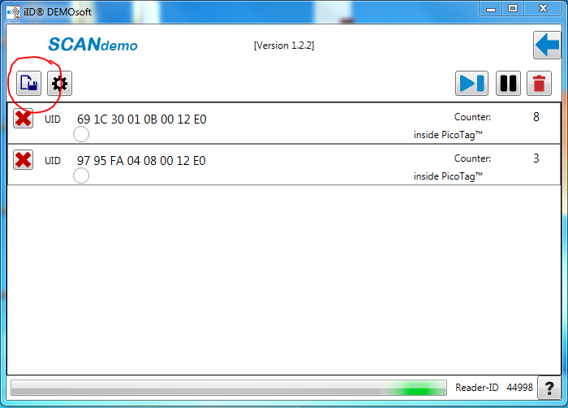 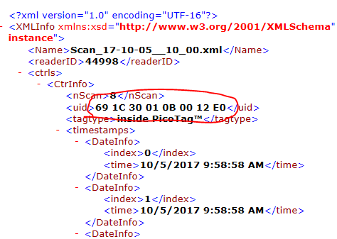

* + You can find the corresponding “Date delivered,” “Date tagged,” and “Cohort #” for each ID in the file “Donna Bombus ID Data”; add this information to the staging area

1. After the bees have starved in the cabinet for at least 2 hours: double check that everyone is still alive, move your staged data up into the active rows, and assign each bee to an enclosure if you haven’t already
2. Starting a foraging trial:

**Prepping the foraging chamber**

* + Wipe the green floor, flowers, and insides of the enclosures with EtOH; wipe the insides of the flowers with an EtOH soaked Q-tip

**Processing**

* In the folders “david hofmann code”-> “Experiment_Matching”->”File at the state of Donnas experiments in summer 2017”->”Experiment_Matching”, open “Experiment_Matching”, and click “►”
* Text will appear in the black space and a window will open asking if you’ve updated the metadata, it should look like this:

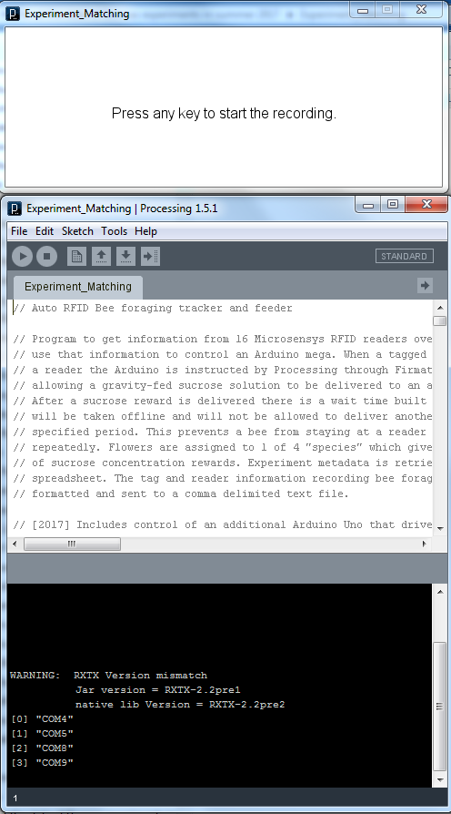

* Follow the instructions in the new window, then test your flowers by inserting the test tag (the strip of post-it attached to a large laminated blue paper flower) into each of them until they light up, which should show up in the black window (see below); a droplet of sugar should appear.

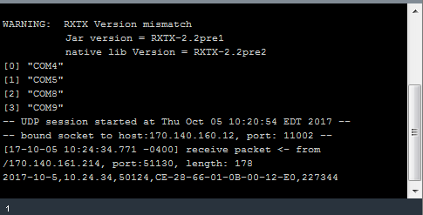

* Great! This means everything is working and bees can be added to the foraging chamber. If the droplet or this series of messages doesn’t appear, you have to restart the foraging chamber. Click “■,” then exit out of the program and start again by reopening your processing file
* If any errors occur, restart the foraging chamber with the above methodology.
* If a pop up appears asking you to update Processing, Firmata, Arduino, or any program related to the foraging trials, DECLINE

**Adding bees to foraging chamber**

* Note the temperature in the foraging chamber and how long the bees have been starving from the timer (in minutes); add this information to the metadata file
* Gently pour the bombus onto the green floor of their assigned enclosure, set the enclosure over them, and make sure the edges of the enclosure are in full contact with the green floor
* **NOTE**: there may be additional set up steps (bubble the bees for 5 minutes, bubble the bees for 5 minutes with decoy bee, etc); the start of the trial is when the bee is released
* When all the bees are in their enclosures, close and lock the doors to the foraging chamber. Note the time the last bee went into an enclosure on the post it and set the other timer for 30 minutes (or whatever length of trial you are using)

1. End of the trial:

* After 30 minutes, end the by trial clicking “■”, then exiting out of the program
* Copy the name of the trial’s .csv file from the “data” folder and add it to the Google doc, along with the ending temperature and any escaped/lost/dead bees
  + Recapture the bees one at a time using the Falcon tubes; they can go back in their subcolonies now
  + Copy all of the active data in the “Donna_Metadata_Worksheet” on the “Human Friendly” tab and paste it into the “Donna_Human Friendly Metadata” file
  + Copy the rows of data in the “Donna_Metadata_Worksheet” on the “R friendly” tab and paste it into the “Donna_Rmetadata” file
  + Update the “Donna Bombus ID Data” file with the name of the foraging trial each bee just completed

1. End of the day:
   * Refill sugar reservoirs up to the 10 mL line
   * Move all new foragingdata (not debugdata) .csv files in the data folder over to Google Drive; drag them to appropriate folder under “Donna Bombus Trials Summer 2017”; repeat with the external hard drive “Foraging Chamber PC External”
   * Delete any mistake .csv files from the data folder